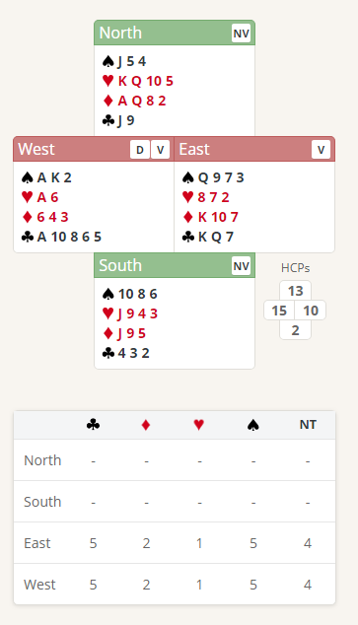
Thursday Bidding Tips 4 (Updated) Board 16 played on 10/5/2018 Hamilton Williams Individual
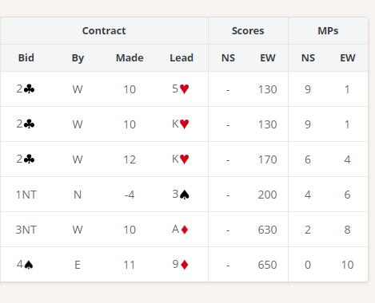

Suggested Bidding 1
N | E Dealer | S | W
 | Pass | Pass | 1C
Double | 1S | Pass | 2NT
Pass | 3NT | All Pass

- Wests bid of 1 Club shows 12-19 points and at Least 4 Clubs.
- Norths Double shows an opening hand (12-19 points) and at least 3 cards in the unbid suits and a shortage in clubs.
- Easts reply of 2 Spade shows 6 plus points and at least 4 spades (you don’t have to jump as West must bud again)
- South with 2 points passes
- West must bid again as East has bid a new suit West with 15 points now knows that there is at least 21 points, so game is possibly on so bids 2 No Trumps to show the 15-16-point range balanced hand and denies having 4 spades.
- East Bids 3 No Trumps showing a 10-12 point balanced hand (and hence not enough for slam), and West plays it in 3 No Trumps
Suggested Lead from North King Hearts (promises the queen and is a signal to south to return the lead)
East takes with Ace and plays the clubs out, ensuring KQ is taken in East first, then the spades out, ensuring AK from west first and should make 10 tricks Ace Hearts ,all the clubs (5), and all the spades (4) and with luck may also get the King of Diamonds ( With a long suit take tricks in the shorter hand first or you may lose the communication between the hands)

